**A network administrator has statically configured the LMI type on the interface of a Cisco router that is running Cisco IOS Release 11.2. If the service provider modifies its own LMI type in the future, what step must the network administrator take?**

The network administrator must modify the keepalive time interval to maintain connectivity with the LMI type of the service provider.  
The network administrator does not have to do anything, because all LMI types are compatible with one another.  
**The network administrator must statically set the LMI type to be compatible with the service provider.\***  
The network administrator simply has to verify connectivity with the provider, because the router has an LMI autosensing feature that automatically detects the LMI type.

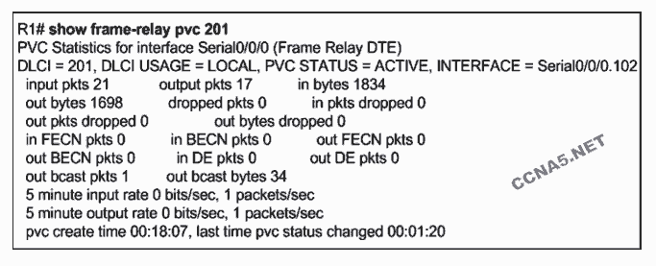

**Refer to the exhibit. Which statement is true about Frame Relay traffic on R1?**

**Traffic that exits subinterface Serial 0/0/0.102 is marked with DLCI 201.\***  
Traffic on Serial 0/0/0 is experiencing congestion between R1 and the Frame Switch.  
Traffic that is mapped to DLCI 201 will exit subinterface Serial 0/0/0.201.  
Frames that enter router R1 from a Frame Relay neighbor will have DLCI 201 in the frame header.

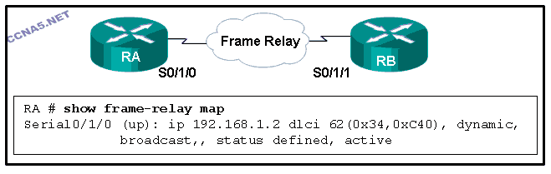

**Refer to the exhibit. Which two statements are correct? (Choose two.)**

The IPv4 address of interface S0/1/0 on RA is 192.168.1.2.  
**The IPv4 address of interface S0/1/1 on RB is 192.168.1.2.\***  
**The DLCI that is attached to the VC on RA to RB is 62.\***  
The DLCI that is attached to the VC on RB to RA is 62.  
The Frame Relay map was set by using the command frame-relay map.

**A router interface connects to a Frame Relay network over a preconfigured logical circuit that does not have a direct electrical connection from end to end. Which type of circuit is being used?**

SVC  
hub and spoke  
full mesh  
dedicated leased line  
**PVC\***

**Why would a customer request a Frame Relay circuit with a CIR of zero?**

to have a circuit used for network management traffic  
to have a backup circuit for critical data transmissions  
to have better QoS  
**to have a link with reduced costs\***  
to have a circuit used for voice traffic

**When would the multipoint keyword be used in Frame Relay PVCs configuration?**

when multicasts must be supported  
when using physical interfaces  
**when participating routers are in the same subnet\***  
when global DLCIs are in use

**Which two Frame Relay router reachability issues are resolved by configuring logical subinterfaces? (Choose two.)**

LMI status inquiry messages sent to the network are not received.  
Inverse ARP fails to associate all IP addresses to the correct DLCIs.  
Frame Relay is unable to map a remote IP address to a DLCI.  
**Distance vector routing protocols are unable to forward routing updates back out the incoming interface to other remote routers.\***  
**Link-state routing protocols are unable to complete neighbor discovery.\***